**Improvements**

The context bar makes everything clearer

The additions of the separate lists are very useful.

Colour schemes and map style are good.

Search function is really helpful.

**Calculation Issues**

1. Screenshots 1 and 2 – different surgeon numbers displayed on map and in information box. Surgeon number are in fact ok. The discrepancy is visible only at the lower zoom levels and this is due to the grouping - clustering of the icons.

I regrouped the icons (created grouping for each district, I think now icons clusters are grouped better. )

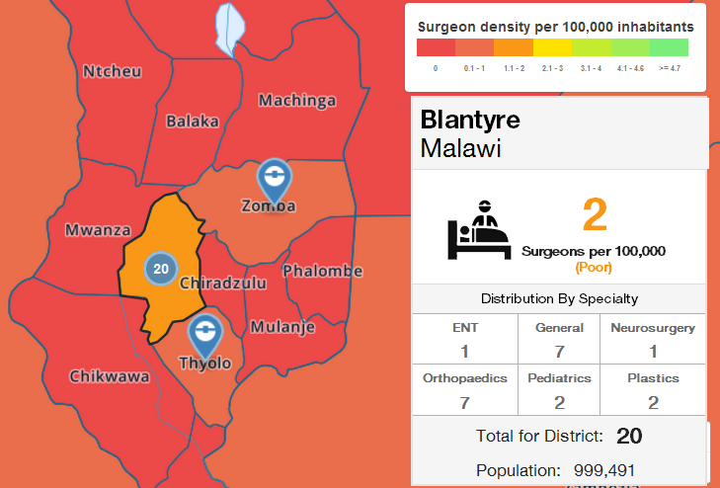

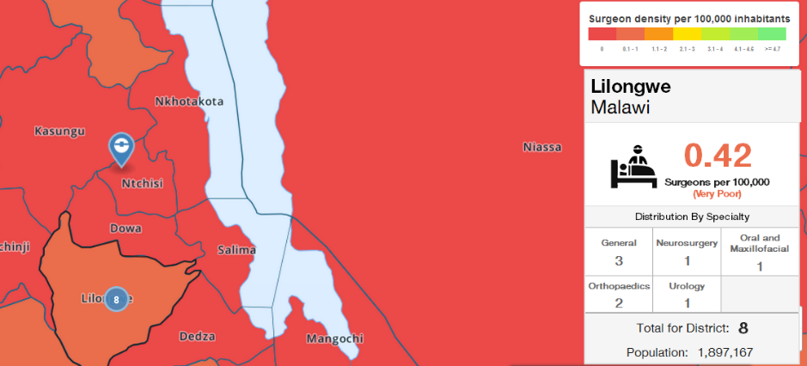

1. Screenshots 3 and 4 – different country level surgeon numbers depending on how zoomed in and out you are
2. Screenshot 5 – Surgeon specialty doesn’t add up to surgeon country total (presumably because there is one surgeon who’s specialty is unknown?)
3. Screenshot 6 – Surgeon population ratio and map show that there is at least one surgeon, but information box on right side doesn’t show any surgeons.

Done…

1. Screenshot 10 – Hospital numbers not calculating correctly. Example shows 55 hospitals and 33 surgeons.

I regrouped the icons (created grouping for each district, I think now icons clusters are grouped better. )

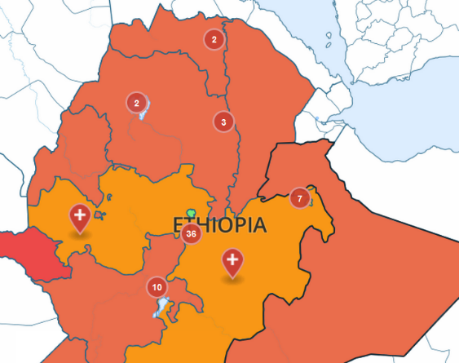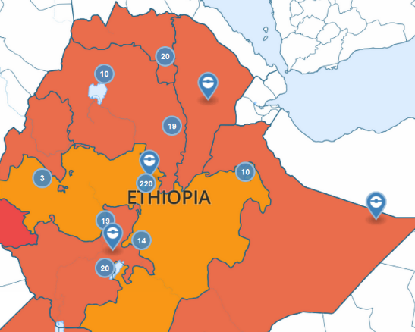

1. Screenshot 12 – Hospital / surgeon numbers not calculating correctly. Example shows a hospital with a surgeon, but information box shows no surgeons in the province.
2. There are two regions in Ethiopia marked as “Addis Ababa” – the small one is correct, the big one is “Oromia”

Name corrected in the database and in local geojson file. Dne and visible in production

**Visual Issues**

1. COSECSA logo will need to be added. Smaller, the RCSI and Irish Aid logos will also need to be added - “Produced in partnership with RCSI and Irish Aid”

Please provide logos

1. For this hospital list – can the pin for training centre specify COSECSA training centre? Perhaps a different colour? – What color? How should this look ?

1. Screenshots 7 and 11- The number “1” on the map seems to show up as a symbol for both surgeons and hospitals – This is done, I have removed the surgeon and hospital icons. It shows 1 now
2. Screenshot 8 – Population number slightly off the bottom of the box – Can’t reproduce, can you cpacify the borwser and OS?
3. Screenshot 9 – A couple of Indian ocean Islands are coloured green but don’t seem to have any info associated with them – These are French overseas territories. In order to remove them I must find the coordinates in the geocoding file and remove them manually. Quite tricky to do, but if it is a must then I don’t heave choice. .. Is it a must ?
4. Hospital list – could it be mentioned that these are the hospitals with qualified surgeons (ie not all hospitals in the region) – Where do I put this ?
5. When using zoom function with symbols for hospitals – okay when zoom in but when zoom out symbols remain and appear overcrowded.

**Content Issues**

1. Remove NGO data from COSECSA version of map – no problem if elsewhere a version exists with this data. Just out of curiosity, where did this data come from?

How should we do this? Just remove the story form produciton site ?

1. Replace references to “East Africa” with “East, Central and Southern Africa” or “COSECSA region” whichever fits best in available space. Updated to “COSECSA region”, both on production and dev sites
2. Update data – CSV attached - did not find any csv attached, can you provide the csv?
3. For any errors that are due to a lack of information (ie. Surgeon specialty, surgeon address etc) could an “unknown” box be created? Can you be more specific on this ?
4. Surgeon density – UK, France and Australia highlighted. Our figure for UK surgeon density population is 13.4 per 100,000. OK, done
5. France (40:100,000) sounds like a bit of a rounded number? For now I am keeping 40